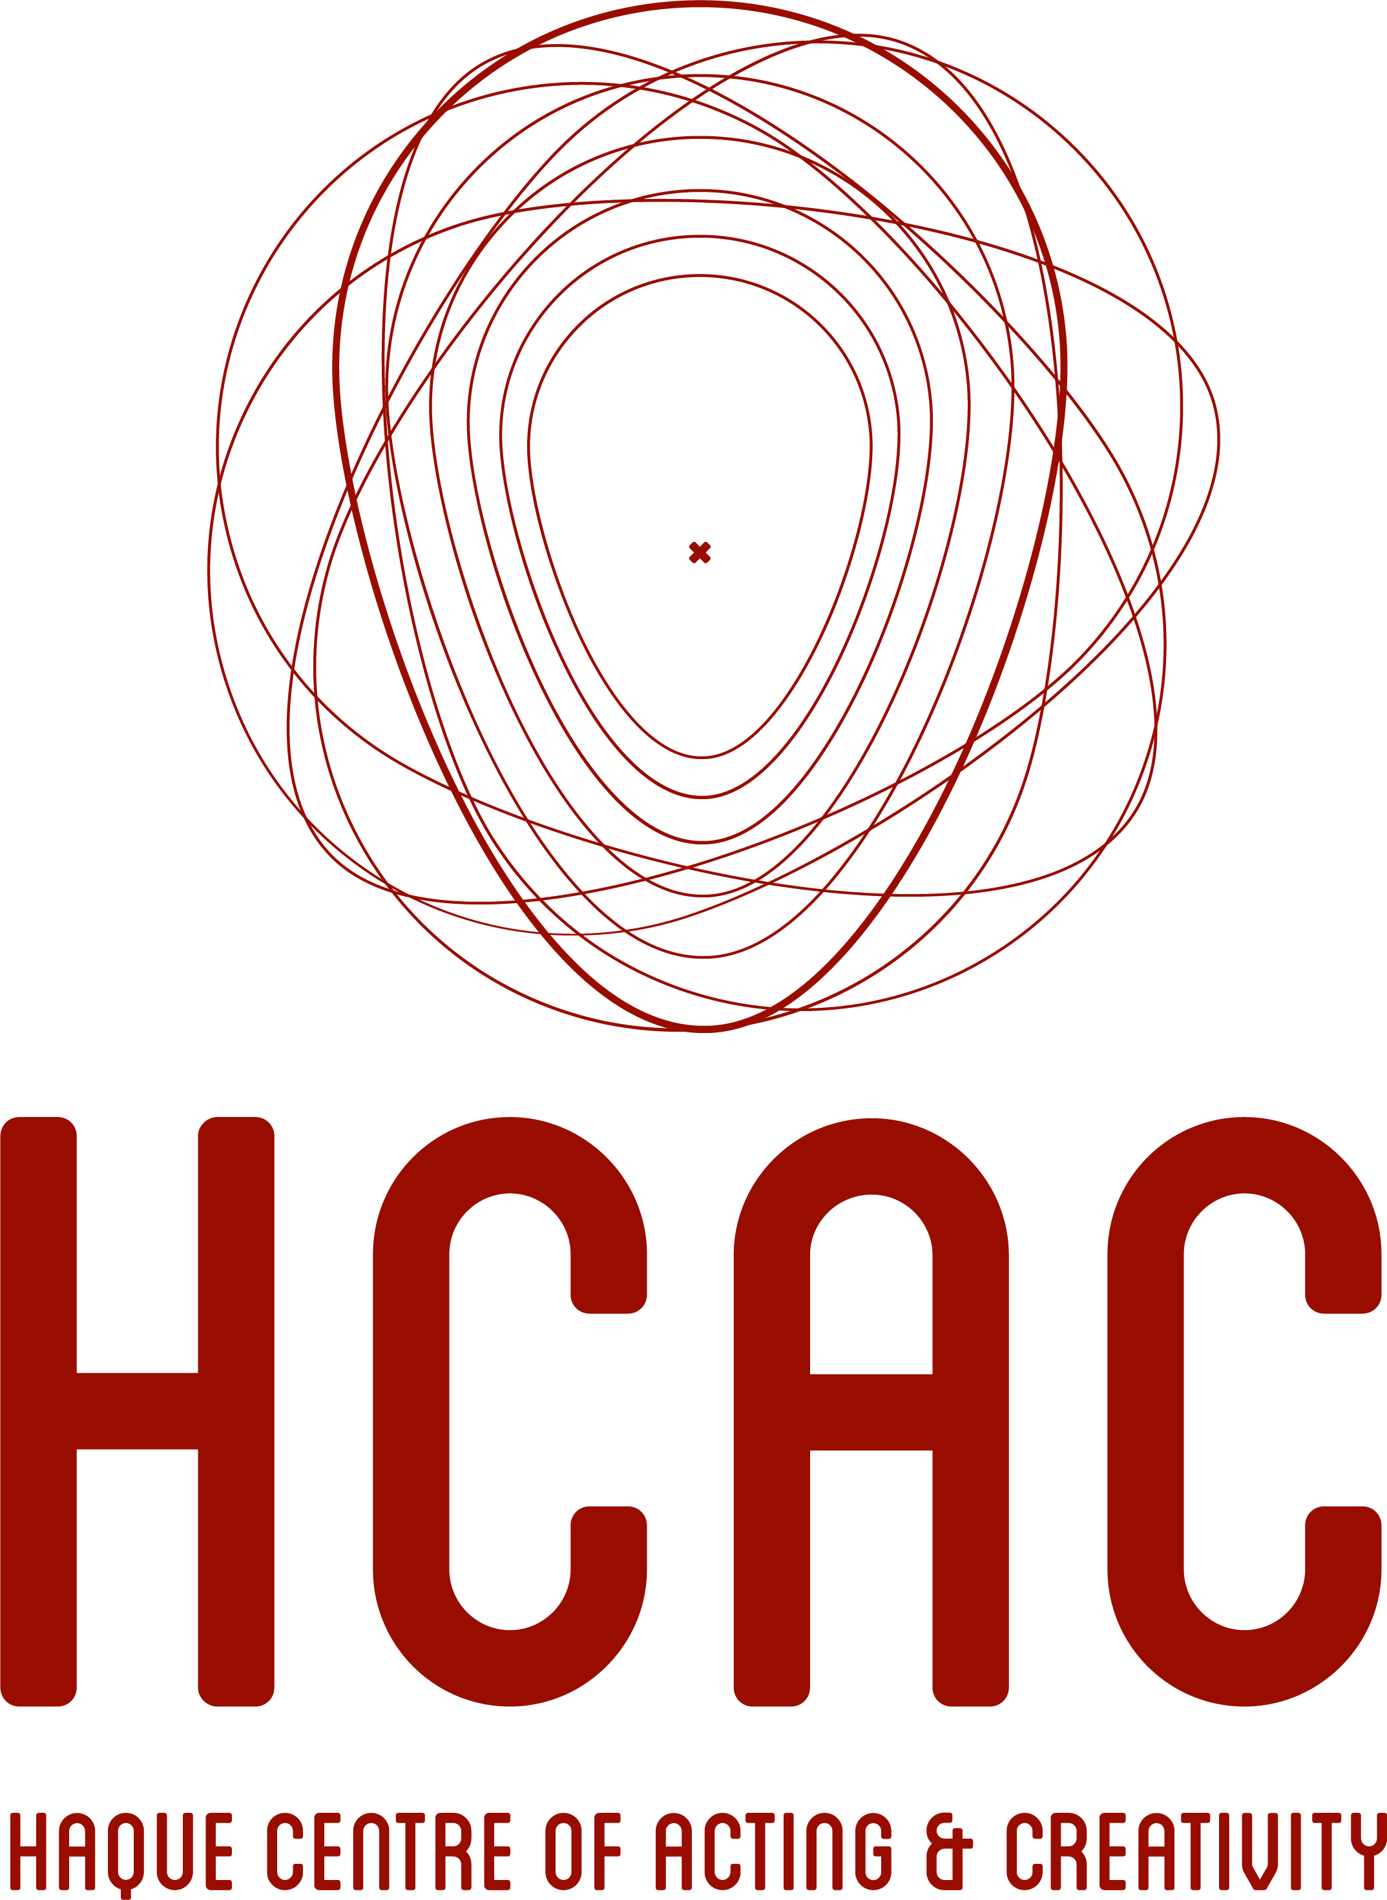

**CASTING TEMPLATE**

|  |
| --- |
| **Project Title:** |
|  |
| **Project Type:** |
|  |
| **Rate/Compensation:** |
|  |
| **Synopsis:** |
|  |
| **\*Role(s):** |
| *Add number of roles where necessary.*  Role #1  Name of character:  Role Description:  Role Type:  Gender:  Age:  Ethnicity:  Role #2  Name of character:  Role Description:  Role Type:  Gender:  Age:  Ethnicity: |
| **Additional Notes (e.g. Audition Dates, Shoot/Show Dates):** |
|  |
| **Contact Details:** |
| Contact Name:  Production Company:  Contact Number(s):  Contact Email(s): |

*\*You may add images in your casting notice where necessary.*

**Terms and Conditions:**

1. **HCAC will not be responsible for the content of the auditions offered and makes no warranty as to their accuracy.**
2. **Auditioners should use their own judgment in agreeing to accept auditions or casting calls through our site.**
3. **We reserve the right, in its sole discretion, to reject, refuse to post at any time, for any or no reason, with or without prior notice or explanation, and without liability.**
4. **Access to our site may be interrupted, restricted or delayed from time to time. We will not be liable for damages or costs in these circumstances.**
5. **All information provided to us must be complete and accurate. If your information changes you will be responsible for providing us with the updated information.**
6. **We shall not be held liable for any loss, damage or consequences as a result of inaccurate or incomplete information we receive from you.**
7. **You agree to release, indemnify and keep indemnified us from and against all actions, claims, costs (including legal costs and expenses) losses, proceedings, damages, liabilities, or demands suffered or incurred by us to any person arising out of or in connection with your use of our services.**